15th December 2016

**YOKOHAMA wins U.K. Tyre Safety Association Award**

Tokyo – The Yokohama Rubber Co., Ltd., is proud to announce that its U.K. tire sales subsidiary Yokohama H.P.T. Ltd. (YHPT) was selected in July as the Tyre Manufacturer of the Year in the 2016 TyreSafe Awards presented by TyreSafe, a nonprofit organization in the United Kingdom that promotes tire safety awareness through activities that encourage drivers to regularly check tire pressure and tread wear.

The award recognizes the tire safety campaign conducted by YHPT in cooperation with the English Premier League’s Chelsea Football Club in the previous October, TyreSafe’s annual Tyre Safety Month. During that month, a total of 132,000 fans attended three Chelsea FC matches at its home stadium at Stamford Bridge and saw members of the Chelsea FC Ladies team highlight the importance of tire safety checks in a special video on the stadium’s main screen.

Since its establishment in 2006, TyreSafe has worked in cooperation with major tire manufacturers, vehicle manufacturers, the media and other industry-related parties to educate and promote the importance of proper tire usage through videos, leaflets, TV and internet advertisements etc. With cooperation from the police, fire department and other local authorities, TyreSafe also holds regular tire pressure checking events in the parking lots of local supermarkets and other places where large numbers of cars can be found.

Thanks in part to TyreSafe’s activities, the number of deaths in the United Kingdom related to vehicle tire problems over the past 10 years has been reduced by 31%.

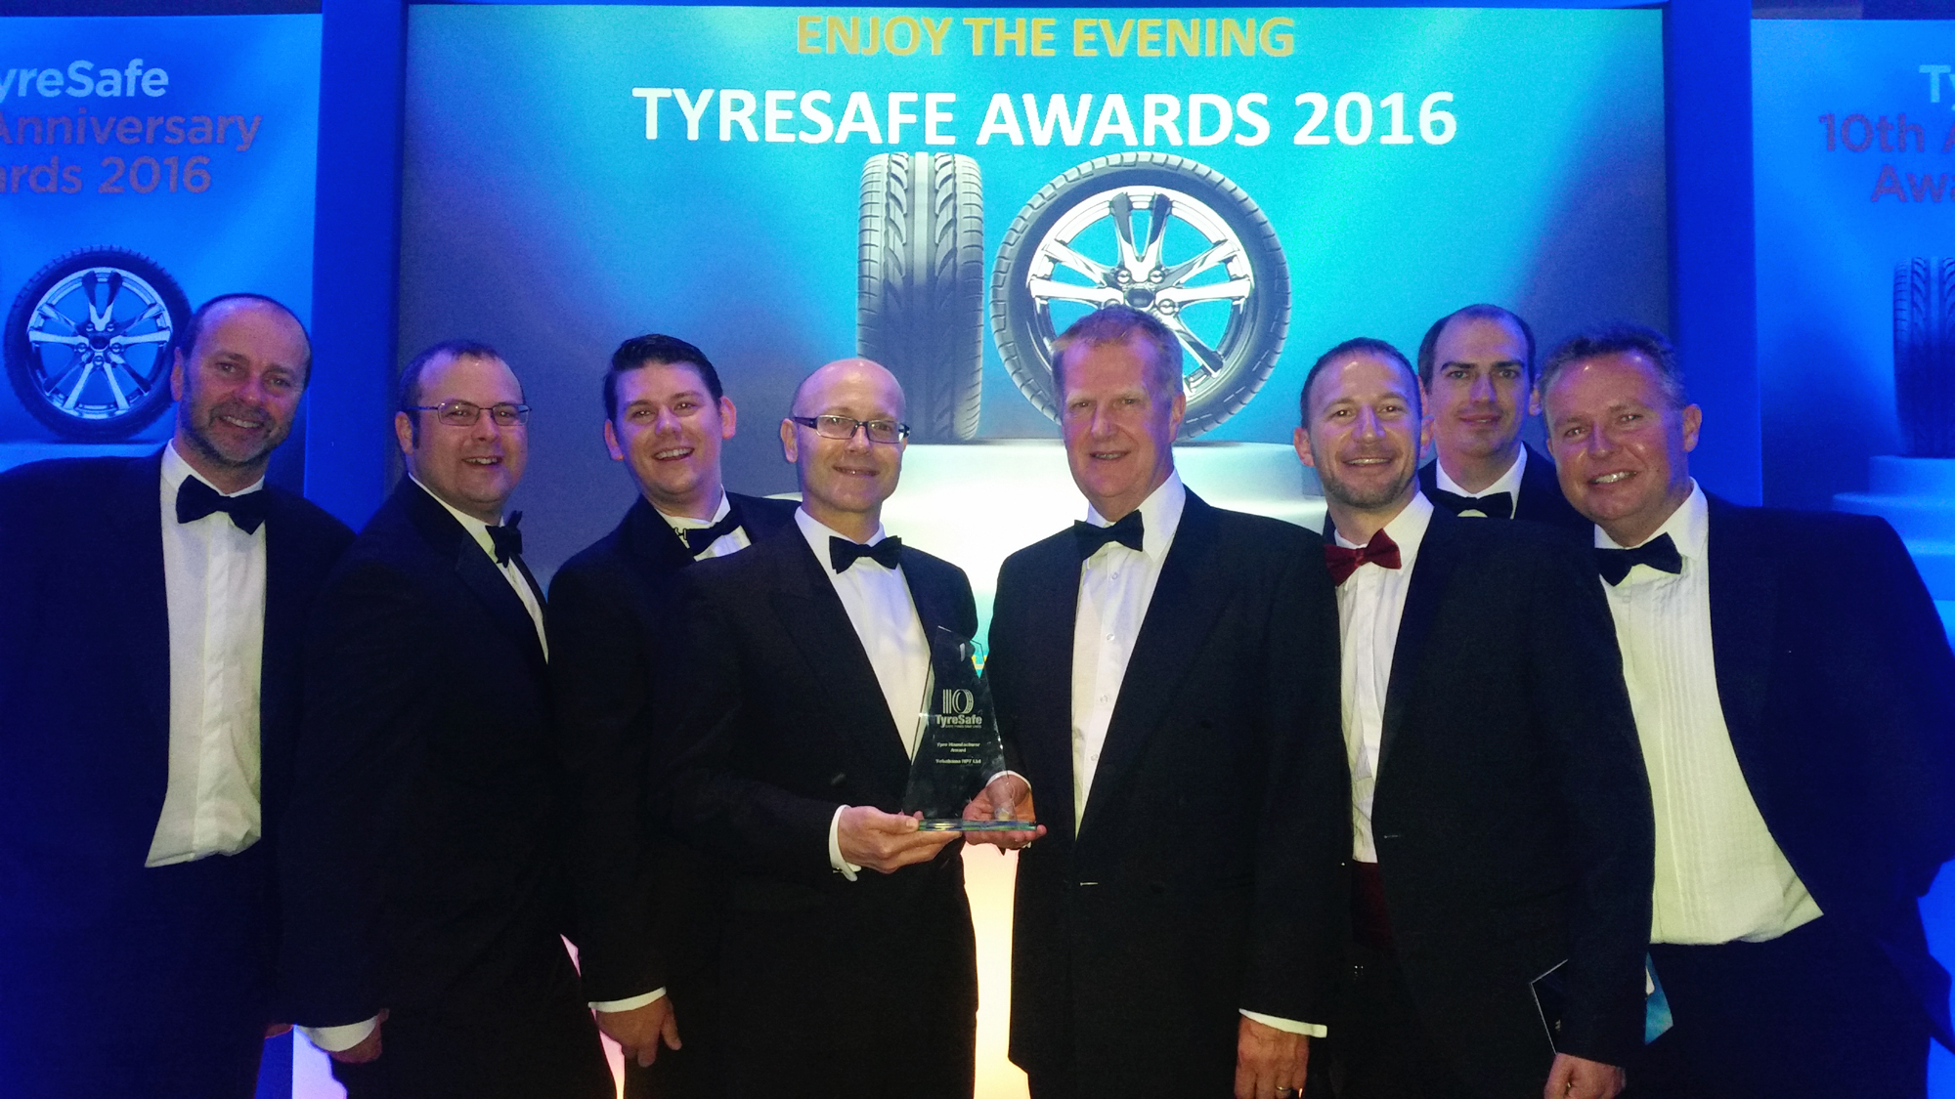

*YHPT members proudly accepting their TyreSafe Award at the awards ceremony in July 2016*